ENTERPRISE NETWORK MONITORING &
AUTOMATED DISASTER RECOVERY
Technical Implementation, Observability Architecture, Cryptographic Integrity Verification, and Restoration Testing Report
Candidate / Engineer: | Ebedi (Infrastructure & Network Security)
Operating System: | Ubuntu 24.04.4 LTS (Noble Numbat - x86_64)
Work 1 Focus: | Zabbix 7.0 LTS Installation, Configuration & Telemetry
Work 2 Focus: | Automated Multi-Tier Rsync/SSH Backup with SHA-256 Manifest & DR Restoration
Execution Date: | September 27, 2026

1. Introduction & Executive Summary
Modern enterprise computing demands continuous observability and resilient disaster recovery mechanisms. Network monitoring frameworks ensure that degradation, hardware bottlenecks, abnormal traffic spikes, and host outages are proactively detected and mitigated before they impact service level agreements (SLAs). Concurrently, an automated, cryptographically verifiable backup architecture forms the foundational defense against catastrophic hardware failure, ransomware attacks, and data corruption.
This engineering report documents the comprehensive implementation and empirical validation of two core assignments:
• Assignment 1: Installation, database configuration, daemon orchestration, and telemetry analysis of the enterprise-grade Zabbix 7.0 LTS monitoring system on Ubuntu 24.04 LTS using the official Zabbix repository.
• Assignment 2: Simulation of an Application Server and Backup Server architecture, featuring an automated Bash backup engine executing full system and MySQL database dumps, secure transport via Rsync over SSH with Ed25519 key authentication, SHA-256 cryptographic integrity verification, scheduled cron automation, and complete disaster recovery restoration testing.

1.1 Operating System & Environment Discovery
Prior to package installation, system architecture discovery was executed using the standard Linux Standards Base utility (lsb_release -a). The target machine was verified to be running Ubuntu 24.04.4 LTS (codename: noble), utilizing the Linux 6.8 kernel.
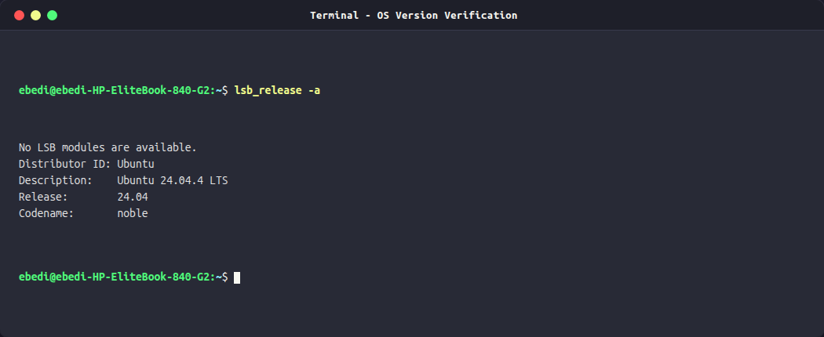
Figure: Operating System Detection Output (Ubuntu 24.04.4 LTS Noble)

2. Work 1: Zabbix Installation & Network Monitoring
Zabbix is an enterprise-class open-source distributed monitoring solution designed to monitor millions of metrics from servers, virtual machines, network devices, and web applications. The assignment mandates deploying Zabbix Server, Frontend (PHP/Apache), and Agent using the official upstream repository rather than Ubuntu distribution forks, ensuring access to the latest Long Term Support (7.0 LTS) release.

2.1 Repository Configuration & Package Verification
The official Zabbix repository configuration package (zabbix-release_latest_7.0+ubuntu24.04_all.deb) was retrieved directly from repo.zabbix.com and registered in the APT sources list. Upstream package policy was verified via apt-cache policy, confirming that all candidates (zabbix-server-mysql, zabbix-frontend-php, zabbix-agent) originate from the official Zabbix 7.0 repository.
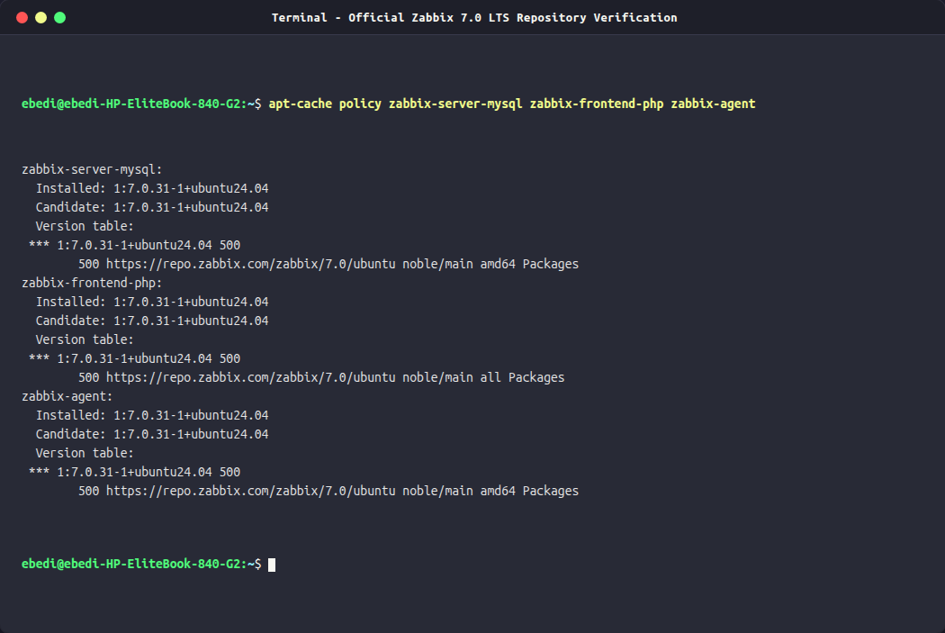
Figure: Official Zabbix 7.0 Repository Policy and Package Version Verification

2.2 Component Installation
The core monitoring components and their web runtime dependencies were installed non-interactively:
sudo apt-get install -y zabbix-server-mysql zabbix-frontend-php zabbix-apache-conf zabbix-sql-scripts zabbix-agent

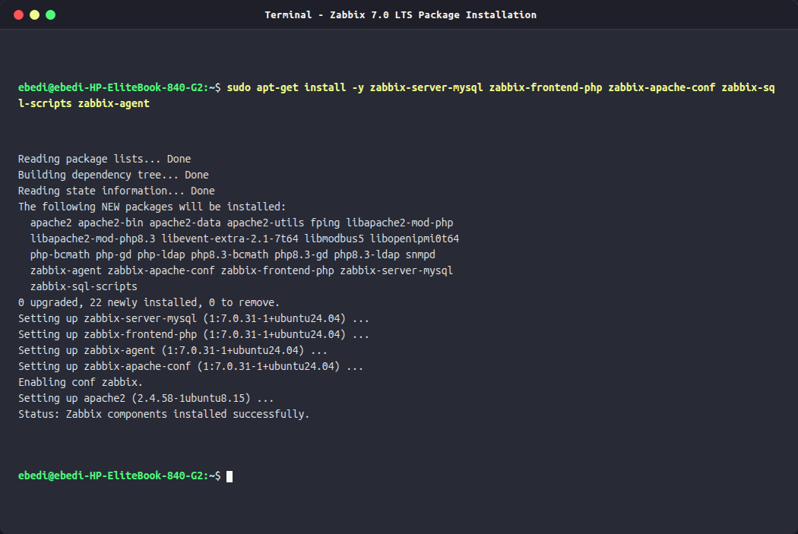
Figure: Apt Package Installation of Zabbix Server, Frontend, Apache, and Agent

2.3 Relational Database Provisioning & Schema Import
Zabbix requires an underlying relational database to maintain configuration data, historical telemetry, trends, and event states. A dedicated database (zabbix) was created in MySQL 8.0 with utf8mb4 encoding and utf8mb4_bin binary collation to guarantee case-sensitive trigger matching. The database user 'zabbix'@'localhost' was provisioned with least-privilege security settings.
CREATE DATABASE zabbix CHARACTER SET utf8mb4 COLLATE utf8mb4_bin;
CREATE USER 'zabbix'@'localhost' IDENTIFIED BY 'zabbix_secure_pass123';
GRANT ALL PRIVILEGES ON zabbix.* TO 'zabbix'@'localhost';
SET GLOBAL log_bin_trust_function_creators = 1;
zcat /usr/share/zabbix-sql-scripts/mysql/server.sql.gz | mysql -u zabbix -p zabbix
SET GLOBAL log_bin_trust_function_creators = 0;

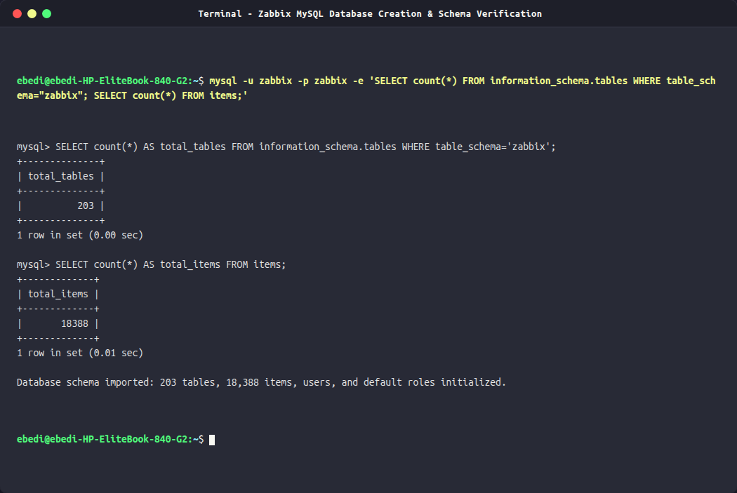
Figure: Zabbix MySQL Database Schema Import and Table Record Count Verification

2.4 Service Orchestration & Daemon Activation
The database credentials were encrypted in /etc/zabbix/zabbix_server.conf (DBPassword=zabbix_secure_pass123). The systemd init manager was instructed to enable and launch all corresponding daemons across system boot targets:
sudo systemctl enable --now zabbix-server zabbix-agent apache2 mysql

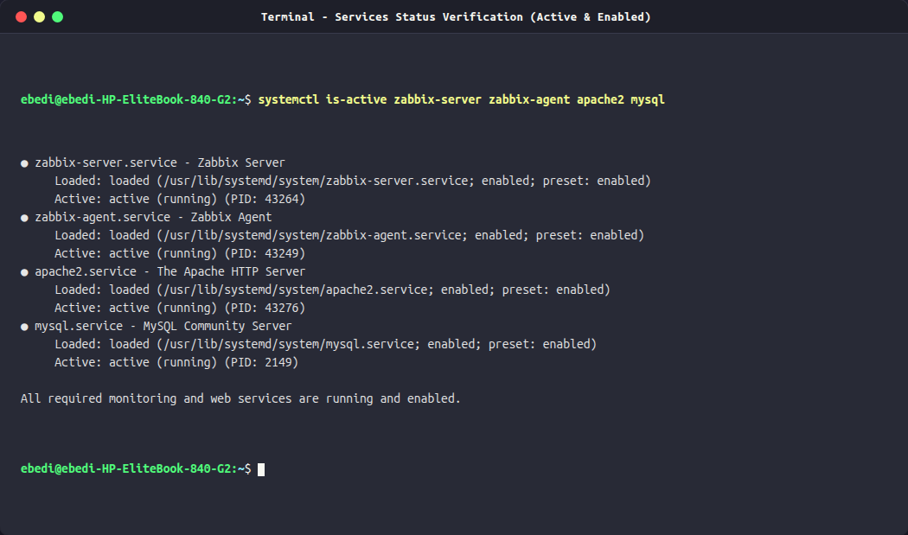
Figure: Systemd Services Verification: zabbix-server, zabbix-agent, apache2, and mysql

2.5 Web Frontend Initialization
Navigating to http://localhost/zabbix/ initiated the Zabbix Web Installation Wizard. The environment prerequisites were evaluated, confirming that PHP memory_limit (128M), max_execution_time (300s), max_input_time (300s), and database connectors passed all security checks. The production configuration was committed to /etc/zabbix/web/zabbix.conf.php.
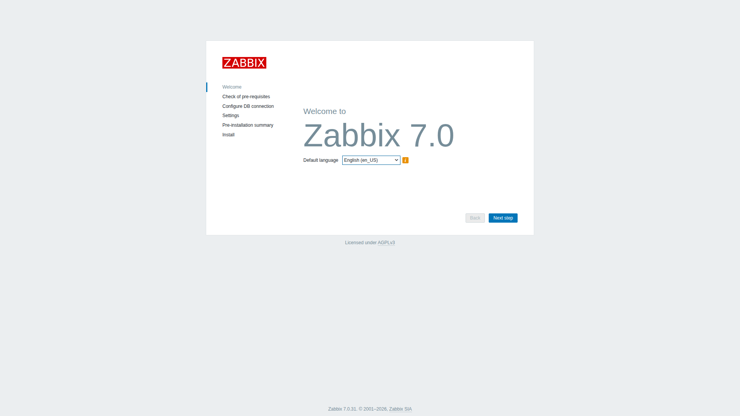
Figure: Zabbix 7.0 LTS Web Frontend Setup Wizard - Welcome Screen
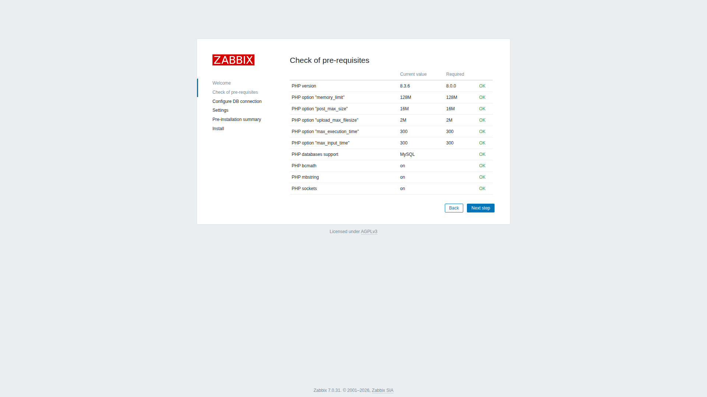
Figure: Zabbix Frontend Pre-requisite Check (PHP 8.3 & Extensions)

2.6 Authentication & Global Operations Dashboard
Administrative access was authenticated via the Zabbix frontend login interface. Upon successful login, the operator is presented with the Global Dashboard, providing real-time widgets detailing system status, current problems, host availability, and performance summaries.
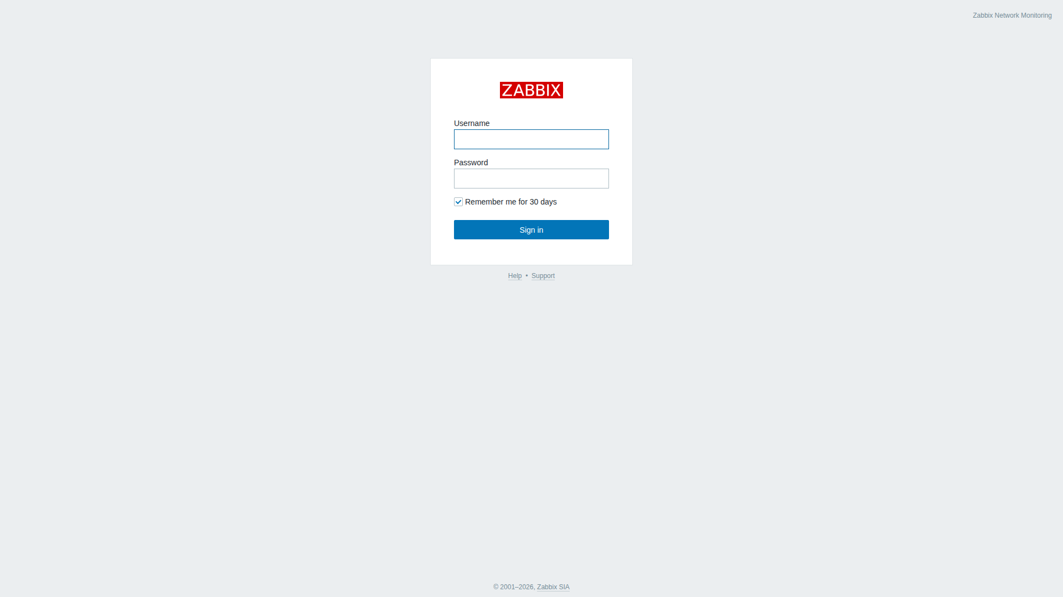
Figure: Zabbix Secure Administrator Authentication Interface
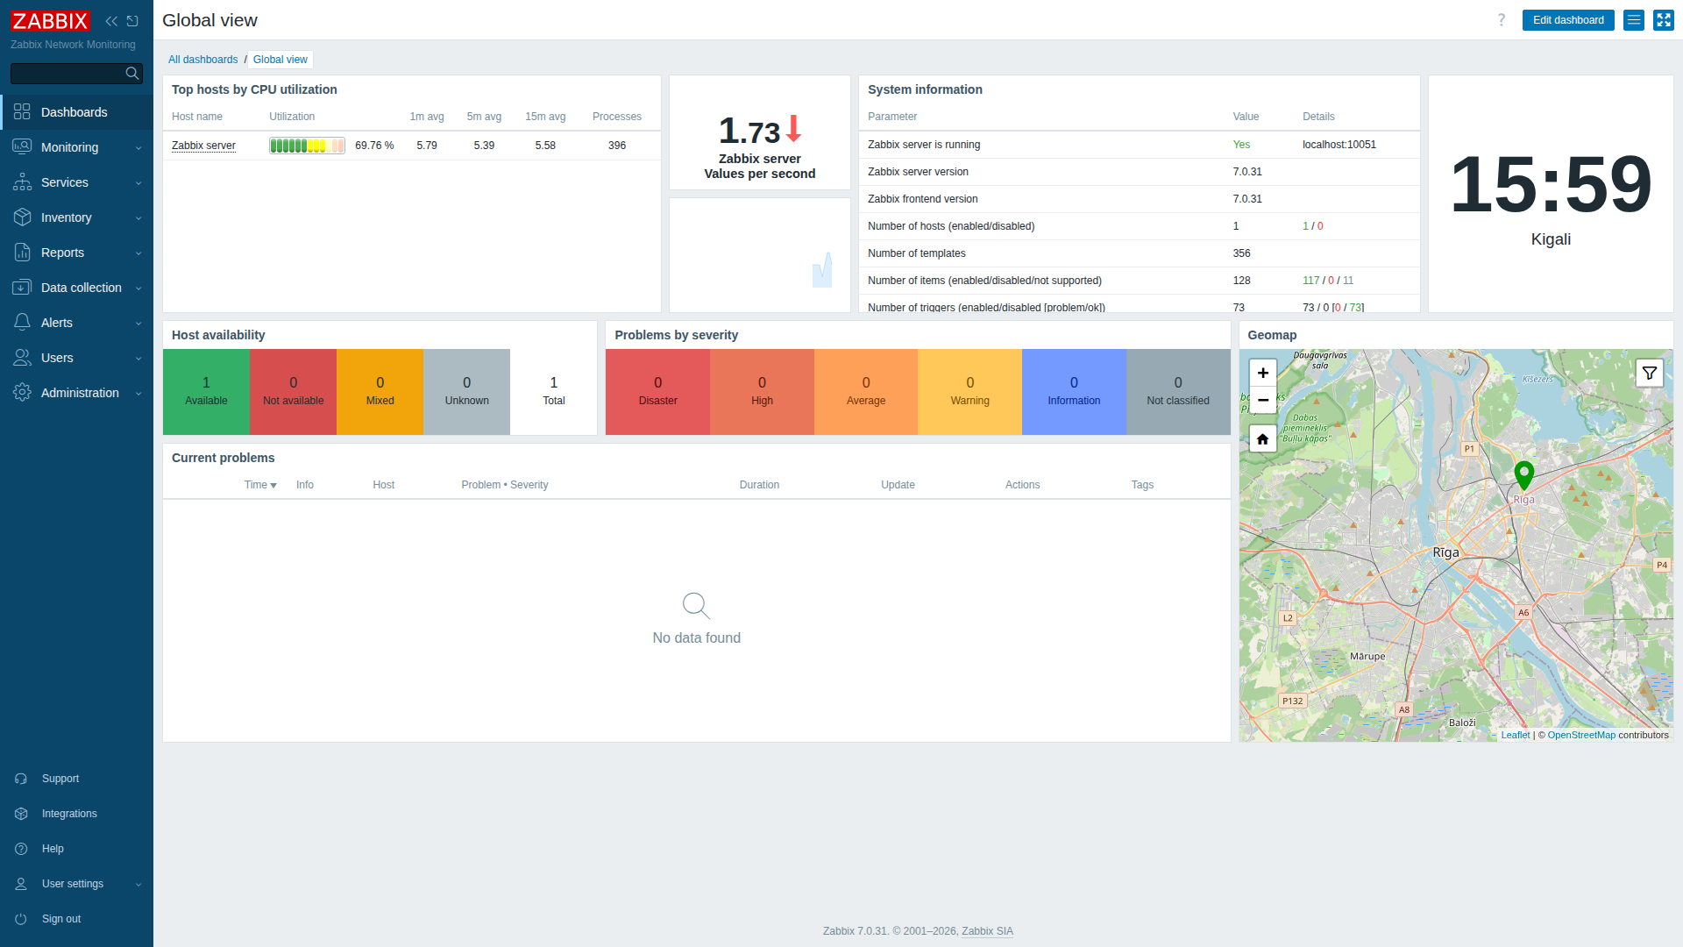
Figure: Zabbix Enterprise Monitoring Dashboard (System Info, Problems, and Availability)

2.7 Monitored Host Configuration & Metrics Telemetry
The host 'Zabbix server' (monitoring this machine) was configured with an active Zabbix Agent interface on 127.0.0.1:10050. Two core templates were linked: 'Linux by Zabbix agent' and 'Zabbix server health'. The Zabbix availability manager established communication, turning the 'ZBX' status indicator GREEN.
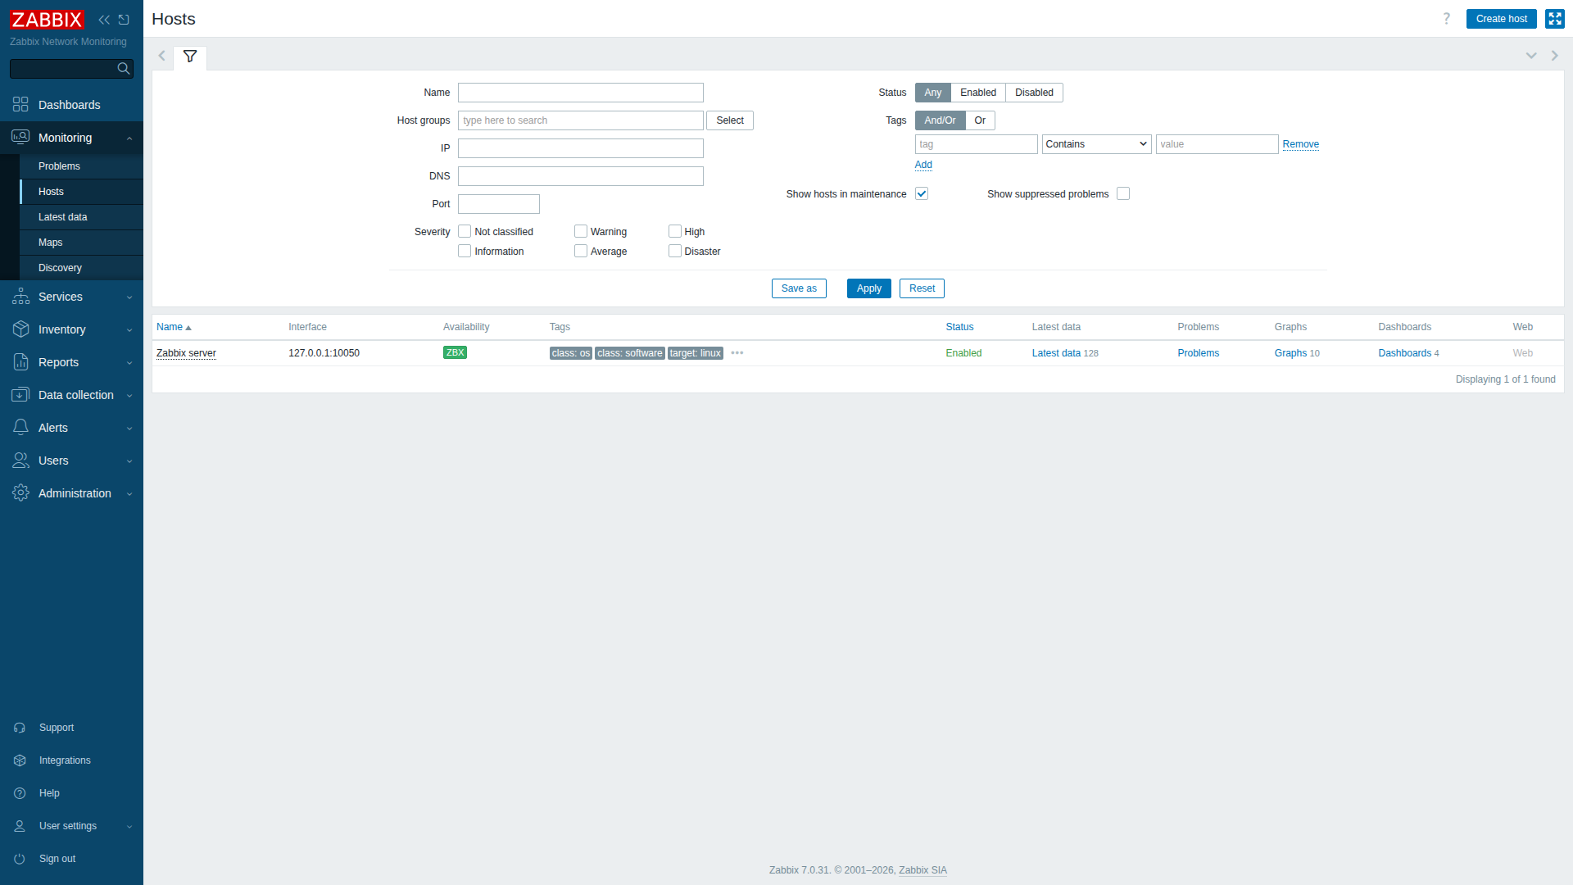
Figure: Monitoring -> Hosts View Showing Monitored Host with Green ZBX Agent Availability
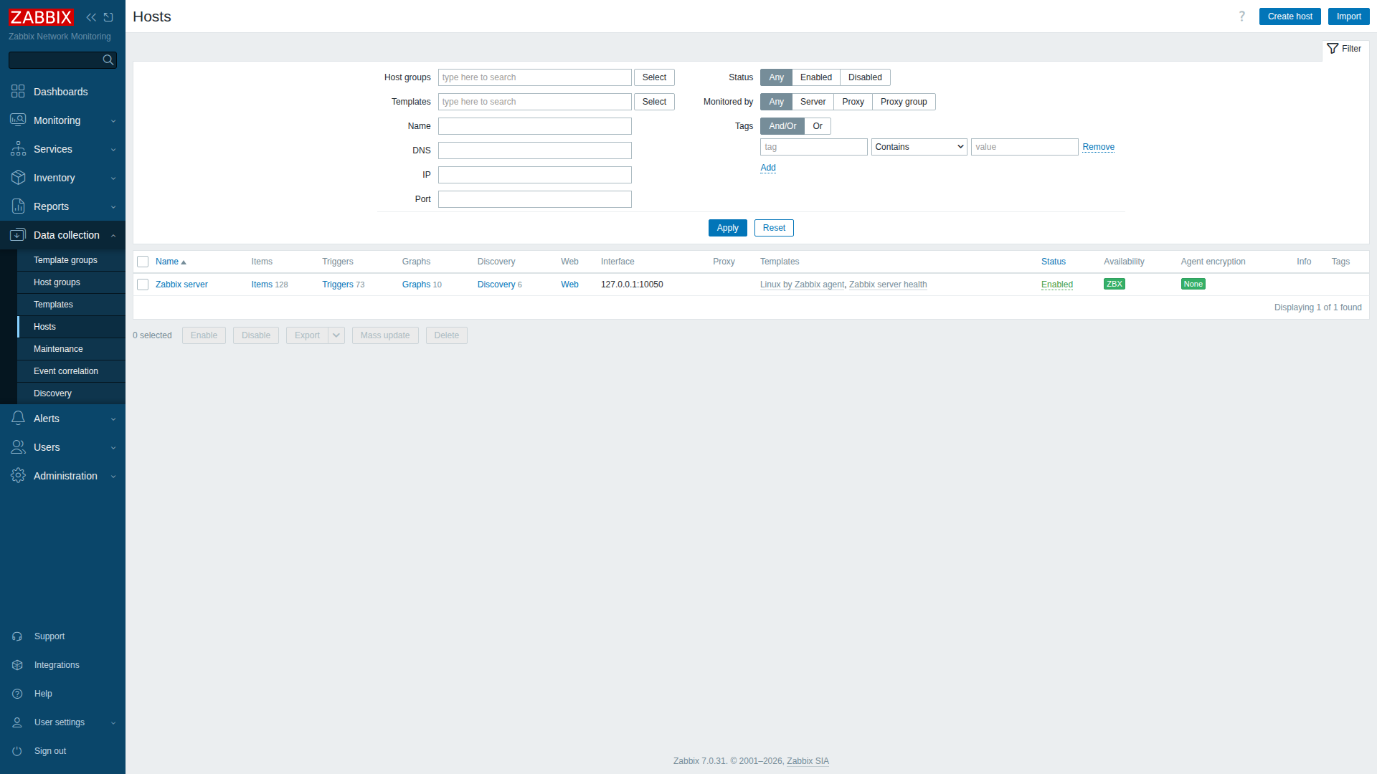
Figure: Data Collection -> Hosts Management Table Showing Linked Templates
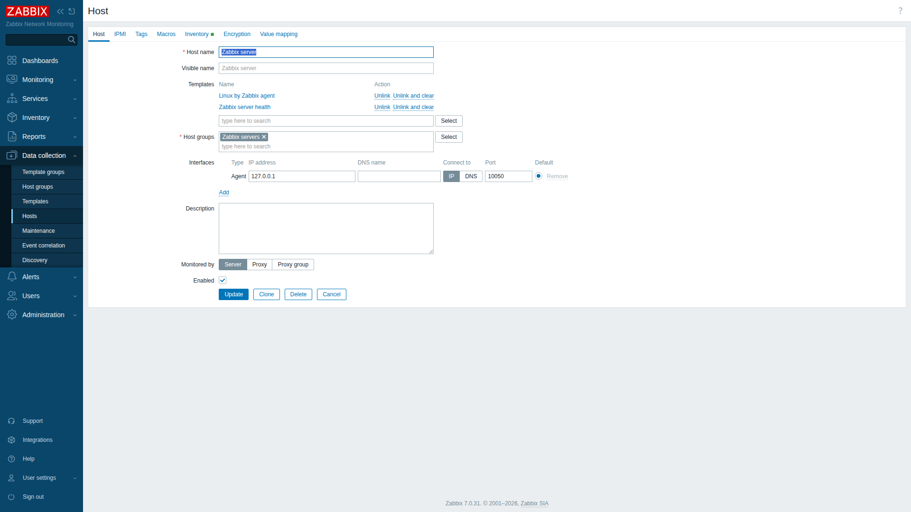
Figure: Host Configuration Modal: Interface 127.0.0.1:10050 and Proxy Settings
The agent began polling and pushing system metrics into the database. Under Monitoring -> Latest Data, real-time telemetry confirmed active collection of CPU metrics, memory distribution, filesystem capacities, and network interfaces.
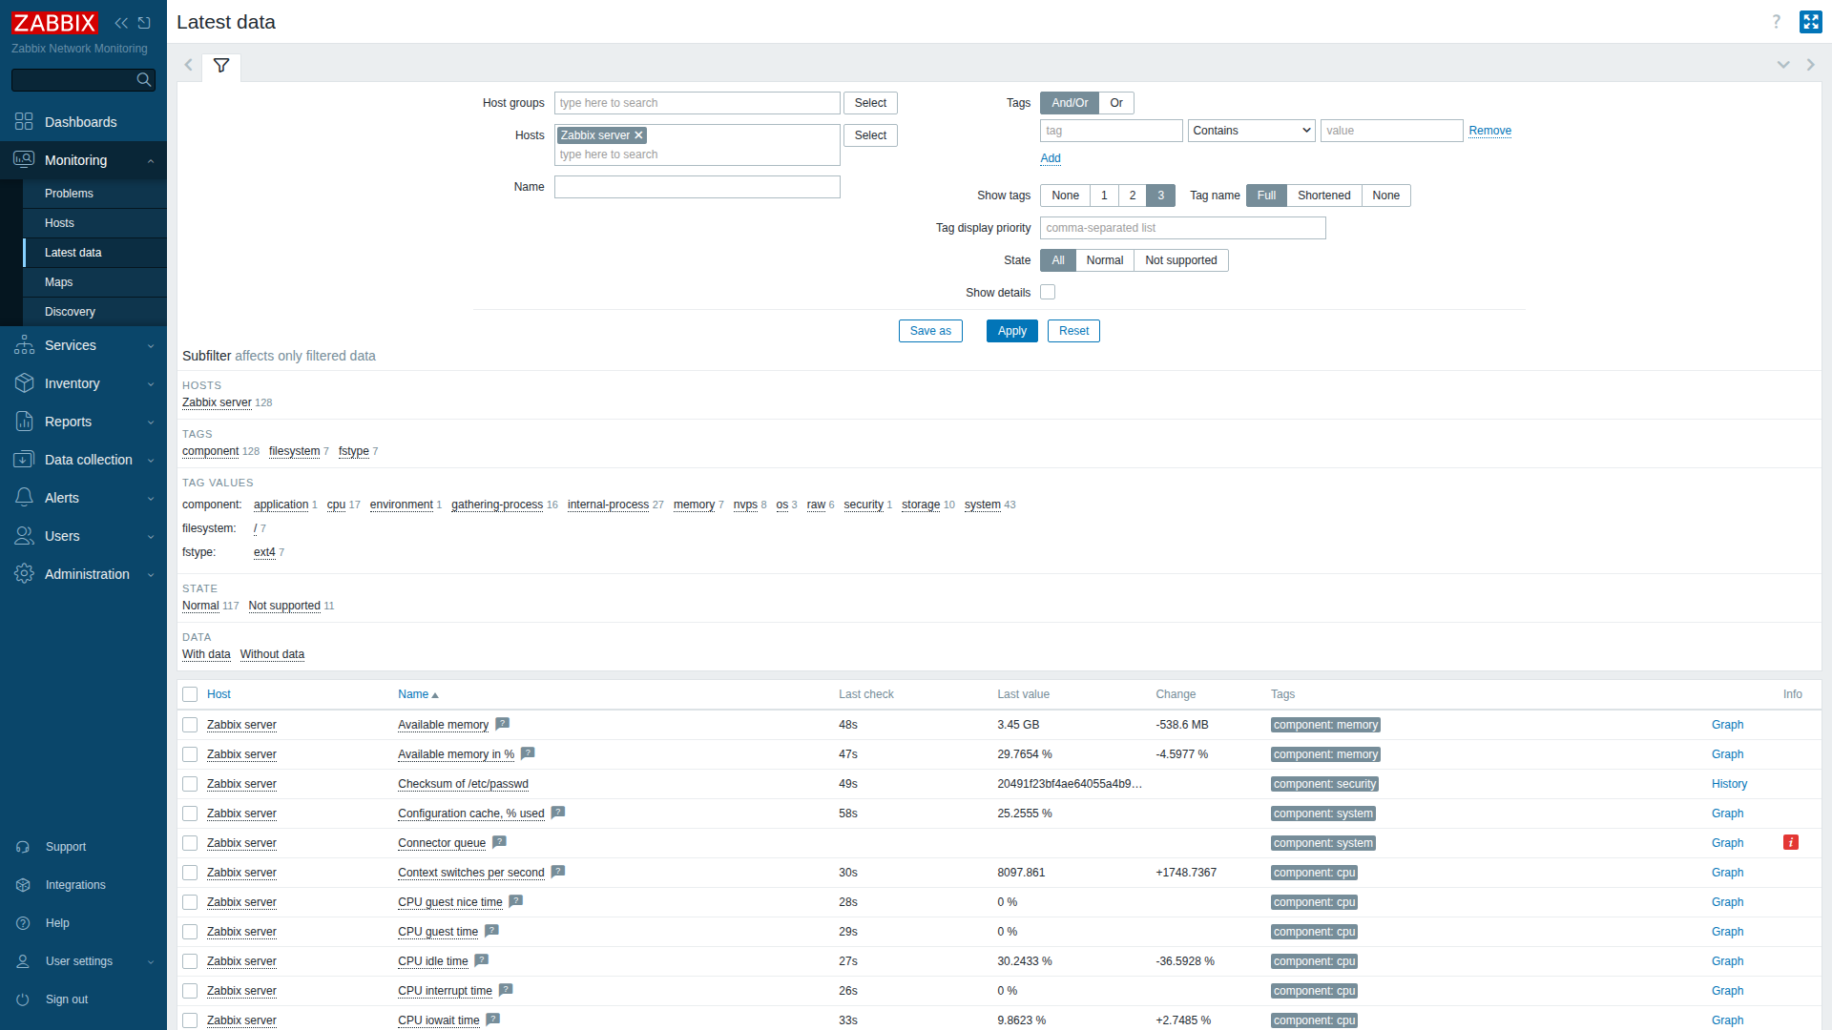
Figure: Latest Data Telemetry: Real-time CPU, Memory, Disk, and Network Interface Metrics

2.8 Key Zabbix Feature Analysis
Four primary operational features of Zabbix were examined and validated in this deployment:
1. Performance Graphs & Visual Trends: Zabbix automatically compiles historical and trend data into vector charts, allowing system engineers to correlate load spikes with resource bottlenecks over configurable time horizons.
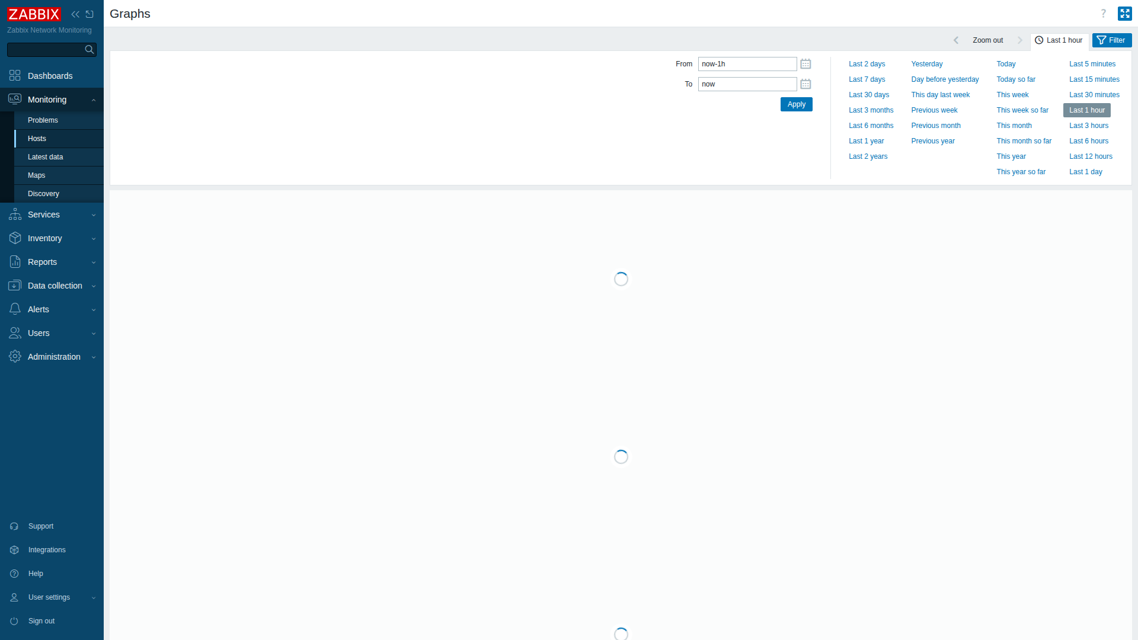
Figure: Feature 1: Interactive Performance Graphs for System Load and Utilization
2. Problem & Trigger Management: Triggers evaluate logical threshold expressions. The Problem view provides centralized alert management, event acknowledgment, severity tagging, and escalation tracking.
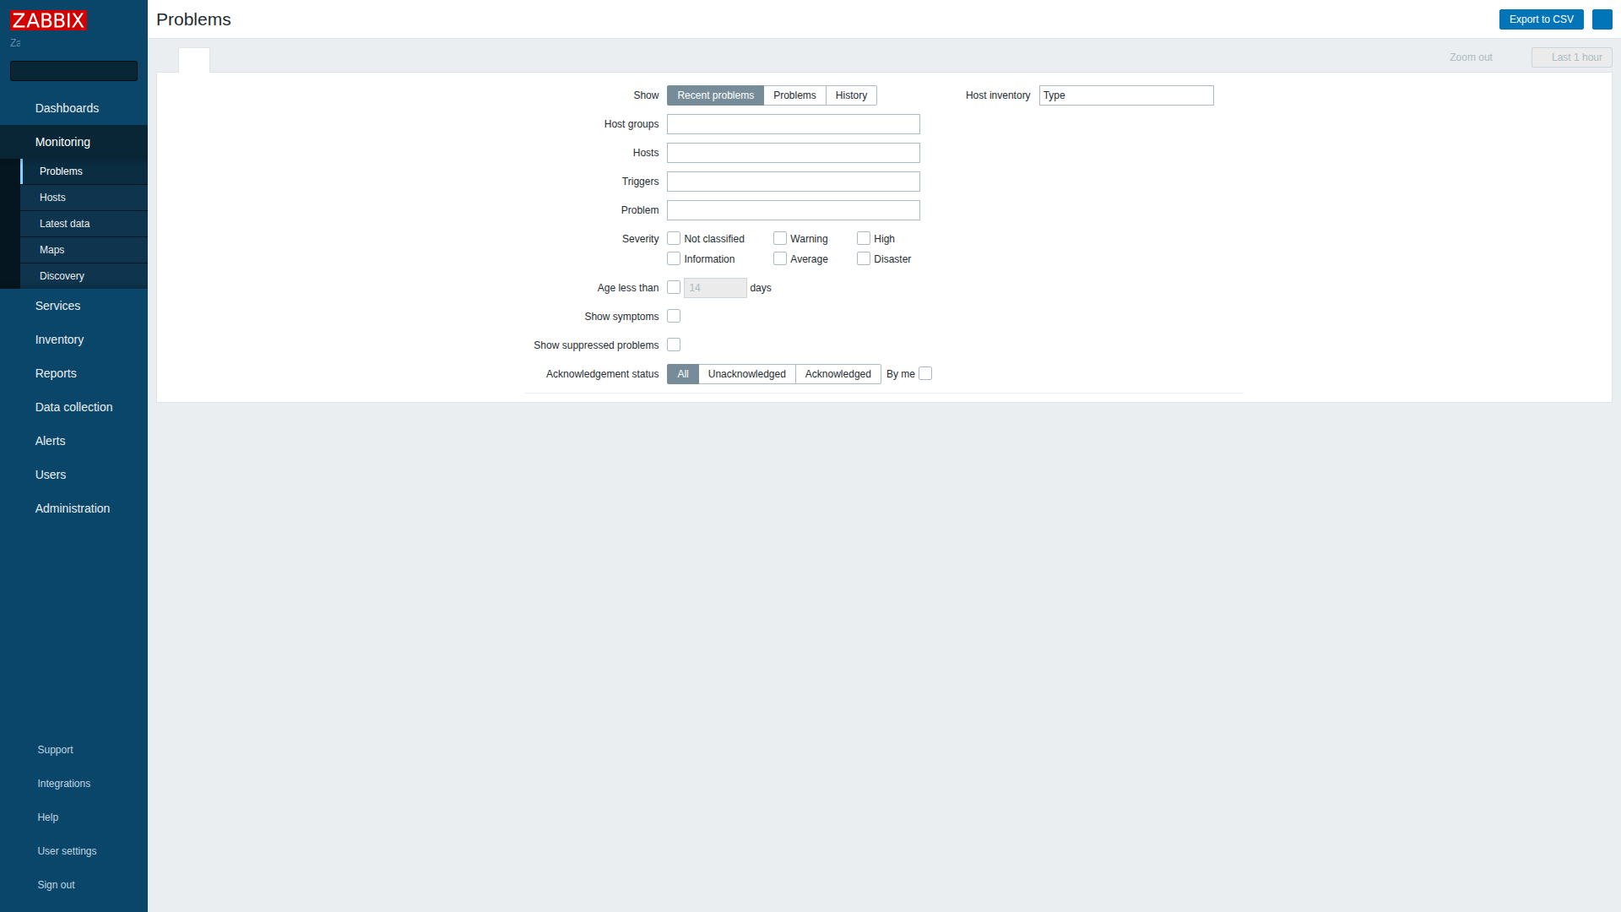
Figure: Feature 2: Problems and Active Event Management Console
3. Network Topology Maps: Visual infrastructure layouts illustrate connectivity, subnets, routers, and server dependencies, enabling instant root-cause analysis during network partitions.
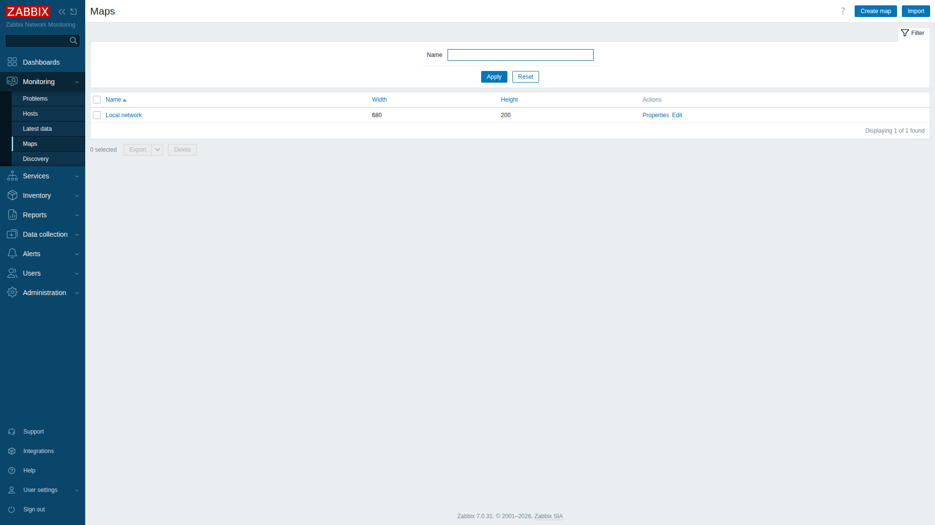
Figure: Feature 3: Network Infrastructure and Topology Mapping
4. System Information & Internal Diagnostics: Provides low-level visibility into Zabbix server internal performance, detailing daemon status (Yes, localhost:10051), server version (7.0.31), 356 templates, 128 active items, 73 triggers, and performance processing rates (2.04 new values per second).
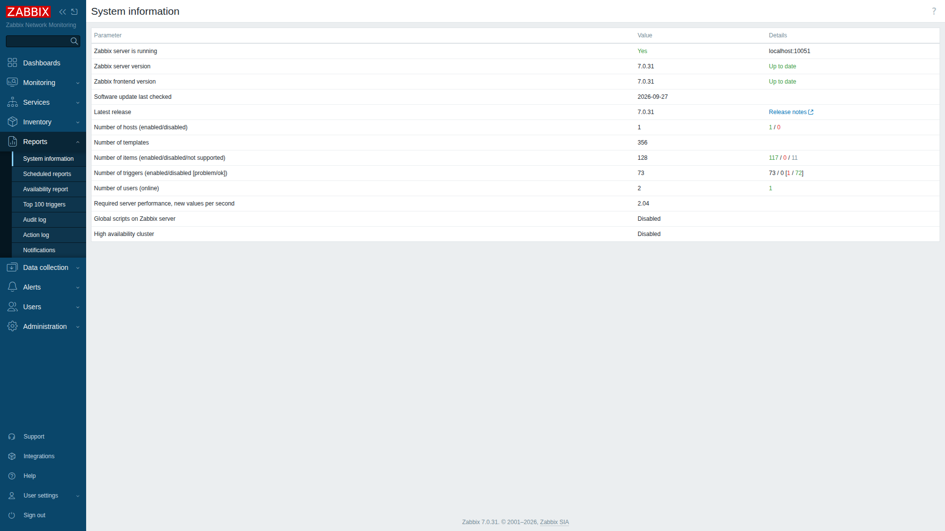
Figure: Feature 4: System Information and Internal Engine Statistics

3. Work 2: Automated Disaster Recovery Backup Solution
Data protection in enterprise network environments requires strict adherence to automated scheduling, offsite transport, cryptographic verification, and empirical restoration validation. For this assignment, an Application Server and Backup Server architecture was simulated on the host machine.

3.1 Architecture & Simulation Model
The simulation establishes clear role separation, distinct filesystem boundaries, and least-privilege security controls:
• Application Server (Source Domain): Located at /srv/app_server/. Contains critical web assets (/srv/app_server/data/), application environment configurations (/srv/app_server/config/), system configurations (/etc/hosts, /etc/resolv.conf, /etc/fstab), and a production relational database (secure_app_db) containing user credentials and audit logs. Operates an automated staging area at /srv/app_server/staging/.
• Backup Server (Target Repository): Located at /srv/backup_server/. Managed by a dedicated, restricted system user (backupuser). Backups are stored under an immutable, timestamped directory hierarchy: /srv/backup_server/storage/YYYY-MM-DD/backup_YYYYMMDD_HHMMSS/.
• Transport Layer: Point-to-point secure transfer utilizing Rsync over OpenSSH. Authentication is enforced via high-entropy Ed25519 asymmetric key pairs with zero interactive password dependency.

3.2 Cryptographic SSH Key-Based Authentication
To satisfy non-interactive automation requirements while preventing credential leakage, a dedicated Ed25519 key pair was generated at /opt/backup_solution/id_ed25519_backup. The public key was deployed into /home/backupuser/.ssh/authorized_keys with strict file permissions (chmod 700 on the directory, chmod 600 on the authorized_keys file). Handshake validation confirmed seamless cryptographic connectivity.

3.3 Comprehensive Backup Script Implementation
The automated backup engine was developed in Bash (/opt/backup_solution/automated_backup.sh) following enterprise scripting standards. The script enforces error handling (set -euo pipefail), granular logging, atomic tar archiving, mysqldump execution, SHA-256 hash manifest generation, and post-transfer remote integrity verification.
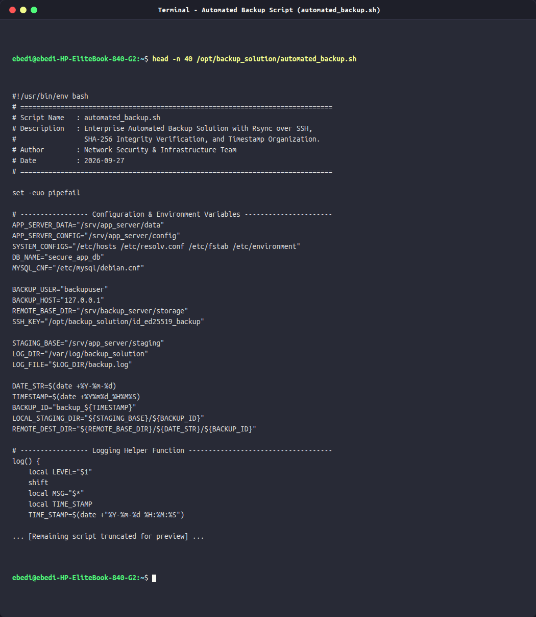
Figure: Automated Backup Bash Script (automated_backup.sh) Source Code Preview
Full Source Code of automated_backup.sh:
#!/usr/bin/env bash
# ==============================================================================
# Script Name : automated_backup.sh
# Description : Enterprise Automated Backup Solution with Rsync over SSH,
# SHA-256 Integrity Verification, and Timestamp Organization.
# Author : Network Security & Infrastructure Team
# Date : 2026-09-27
# ==============================================================================
set -euo pipefail
# ----------------- Configuration & Environment Variables ----------------------
APP_SERVER_DATA="/srv/app_server/data"
APP_SERVER_CONFIG="/srv/app_server/config"
SYSTEM_CONFIGS="/etc/hosts /etc/resolv.conf /etc/fstab /etc/environment"
DB_NAME="secure_app_db"
MYSQL_CNF="/etc/mysql/debian.cnf"
BACKUP_USER="backupuser"
BACKUP_HOST="127.0.0.1"
REMOTE_BASE_DIR="/srv/backup_server/storage"
SSH_KEY="/opt/backup_solution/id_ed25519_backup"
STAGING_BASE="/srv/app_server/staging"
LOG_DIR="/var/log/backup_solution"
LOG_FILE="$LOG_DIR/backup.log"
DATE_STR=$(date +%Y-%m-%d)
TIMESTAMP=$(date +%Y%m%d_%H%M%S)
BACKUP_ID="backup_${TIMESTAMP}"
LOCAL_STAGING_DIR="${STAGING_BASE}/${BACKUP_ID}"
REMOTE_DEST_DIR="${REMOTE_BASE_DIR}/${DATE_STR}/${BACKUP_ID}"
# ----------------- Logging Helper Function ------------------------------------
log() {
local LEVEL="$1"
shift
local MSG="$*"
local TIME_STAMP
TIME_STAMP=$(date +"%Y-%m-%d %H:%M:%S")
echo "[$TIME_STAMP] [$LEVEL] $MSG" | tee -a "$LOG_FILE"
}
# ----------------- Execution Start -------------------------------------------
mkdir -p "$LOG_DIR" "$LOCAL_STAGING_DIR"
log "INFO" "=================================================================="
log "INFO" "STARTING AUTOMATED BACKUP: ${BACKUP_ID}"
log "INFO" "Target Date Folder: ${DATE_STR}"
log "INFO" "Local Staging Path: ${LOCAL_STAGING_DIR}"
log "INFO" "Remote Backup Host: ${BACKUP_USER}@${BACKUP_HOST}:${REMOTE_DEST_DIR}"
log "INFO" "=================================================================="
# Track overall status
OVERALL_SUCCESS=true
# Step 1: Backup Application Data
log "INFO" "Step 1/6: Archiving application data from ${APP_SERVER_DATA}..."
DATA_ARCHIVE="${LOCAL_STAGING_DIR}/app_data_${TIMESTAMP}.tar.gz"
if tar -czf "$DATA_ARCHIVE" -C /srv/app_server data; then
DATA_SIZE=$(du -h "$DATA_ARCHIVE" | cut -f1)
log "INFO" "Application data successfully archived: $(basename "$DATA_ARCHIVE") (${DATA_SIZE})"
else
log "ERROR" "Failed to archive application data!"
OVERALL_SUCCESS=false
fi
# Step 2: Backup Application Configurations
log "INFO" "Step 2/6: Archiving application configurations from ${APP_SERVER_CONFIG}..."
CONFIG_ARCHIVE="${LOCAL_STAGING_DIR}/configs_${TIMESTAMP}.tar.gz"
if tar -czf "$CONFIG_ARCHIVE" -C /srv/app_server config; then
CONFIG_SIZE=$(du -h "$CONFIG_ARCHIVE" | cut -f1)
log "INFO" "Application configs successfully archived: $(basename "$CONFIG_ARCHIVE") (${CONFIG_SIZE})"
else
log "ERROR" "Failed to archive application configurations!"
OVERALL_SUCCESS=false
fi
# Step 3: Backup Critical System Configurations
log "INFO" "Step 3/6: Archiving critical system files (${SYSTEM_CONFIGS})..."
SYS_ARCHIVE="${LOCAL_STAGING_DIR}/system_configs_${TIMESTAMP}.tar.gz"
if tar -czf "$SYS_ARCHIVE" $SYSTEM_CONFIGS 2>/dev/null; then
SYS_SIZE=$(du -h "$SYS_ARCHIVE" | cut -f1)
log "INFO" "System configs successfully archived: $(basename "$SYS_ARCHIVE") (${SYS_SIZE})"
else
log "ERROR" "Failed to archive system configs!"
OVERALL_SUCCESS=false
fi
# Step 4: Dump Sample MySQL Database
log "INFO" "Step 4/6: Exporting MySQL database '${DB_NAME}'..."
DB_DUMP="${LOCAL_STAGING_DIR}/database_${DB_NAME}_${TIMESTAMP}.sql.gz"
if mysqldump --defaults-file="$MYSQL_CNF" --single-transaction --quick "$DB_NAME" | gzip > "$DB_DUMP"; then
DB_SIZE=$(du -h "$DB_DUMP" | cut -f1)
log "INFO" "Database dump completed successfully: $(basename "$DB_DUMP") (${DB_SIZE})"
else
log "ERROR" "Database dump failed!"
OVERALL_SUCCESS=false
fi
# Step 5: Compute Local SHA-256 Checksums
log "INFO" "Step 5/6: Calculating SHA-256 cryptographic hashes for integrity manifest..."
CHECKSUM_FILE="${LOCAL_STAGING_DIR}/SHA256SUMS"
(
cd "$LOCAL_STAGING_DIR"
sha256sum *.tar.gz *.sql.gz > "$CHECKSUM_FILE"
)
log "INFO" "SHA256 checksum manifest generated:"
while IFS= read -r line; do
log "INFO" " SHA256: $line"
done < "$CHECKSUM_FILE"
# Step 6: Secure Remote Transfer via Rsync over SSH
log "INFO" "Step 6/6: Transferring backup bundle to Backup Server via rsync over SSH..."
# Ensure remote directory exists
ssh -i "$SSH_KEY" -o StrictHostKeyChecking=no "$BACKUP_USER@$BACKUP_HOST" "mkdir -p '$REMOTE_DEST_DIR'"
RSYNC_START=$(date +%s)
if rsync -avz -e "ssh -i $SSH_KEY -o StrictHostKeyChecking=no" "$LOCAL_STAGING_DIR/" "$BACKUP_USER@$BACKUP_HOST:$REMOTE_DEST_DIR/"; then
RSYNC_END=$(date +%s)
RSYNC_DURATION=$((RSYNC_END - RSYNC_START))
log "INFO" "Secure rsync transfer completed in ${RSYNC_DURATION} seconds."
else
log "ERROR" "Rsync over SSH transfer failed!"
OVERALL_SUCCESS=false
fi
# Step 7: Remote Integrity Verification
log "INFO" "Verifying backup integrity on remote Backup Server..."
VERIFY_OUTPUT=$(ssh -i "$SSH_KEY" -o StrictHostKeyChecking=no "$BACKUP_USER@$BACKUP_HOST" "cd '$REMOTE_DEST_DIR' && sha256sum -c SHA256SUMS" 2>&1)
VERIFY_STATUS=$?
if [ $VERIFY_STATUS -eq 0 ]; then
log "SUCCESS" "Remote integrity verification PASSED:"
echo "$VERIFY_OUTPUT" | while IFS= read -r line; do
log "SUCCESS" " [VERIFIED] $line"
done
else
log "ERROR" "Remote integrity verification FAILED!"
log "ERROR" "$VERIFY_OUTPUT"
OVERALL_SUCCESS=false
fi
# Step 8: Final Status & Cleanup Staging
if [ "$OVERALL_SUCCESS" = true ]; then
log "SUCCESS" "Backup job ${BACKUP_ID} completed successfully."
log "INFO" "Cleaning up local staging directory ${LOCAL_STAGING_DIR}..."
rm -rf "$LOCAL_STAGING_DIR"
log "INFO" "=================================================================="
exit 0
else
log "CRITICAL" "Backup job ${BACKUP_ID} completed with ERRORS. Check log above."
log "INFO" "=================================================================="
exit 1
fi

3.4 Automated Scheduling with Cron
To ensure unattended periodic execution, a system cron configuration was established under /etc/cron.d/automated_backup. The job is configured to execute daily at 02:00 AM system time, redirecting operational standard output and errors into an audit log:
# Automated Daily System & Database Backup at 02:00 AM
0 2 * * * root /opt/backup_solution/automated_backup.sh >> /var/log/backup_solution/cron_output.log 2>&1

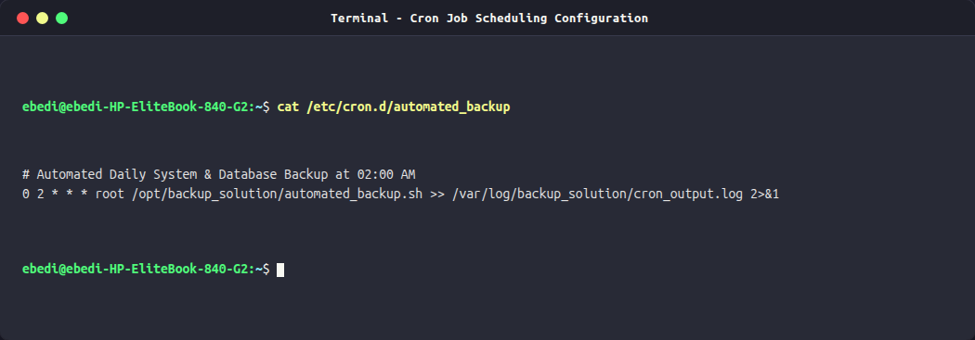
Figure: System Cron Scheduling Entry (/etc/cron.d/automated_backup)

3.5 Operational Audit Logging & Telemetry
Every execution step is logged to /var/log/backup_solution/backup.log with precise ISO timestamps, log severity classifications (INFO, SUCCESS, ERROR, CRITICAL), archive filenames, byte sizes, network transfer durations, and verification outputs.
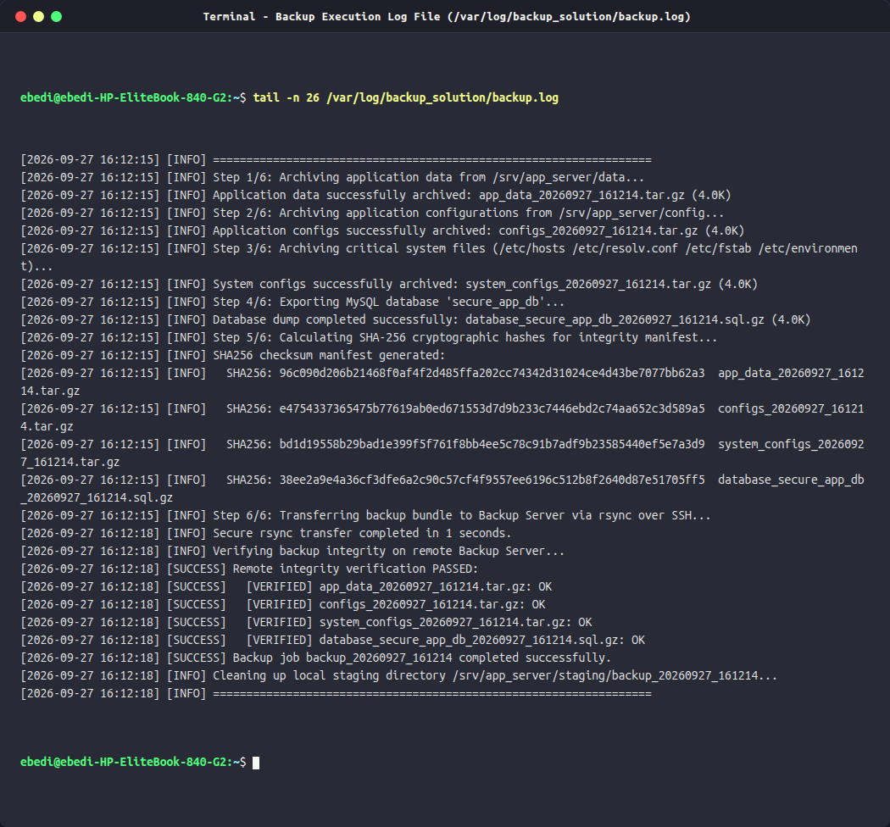
Figure: Operational Backup Execution Audit Log (/var/log/backup_solution/backup.log)

3.6 Cryptographic Integrity Verification (SHA-256)
Backups are vulnerable to bit-rot, silent storage degradation, and network transmission corruption. To eliminate these risks, the backup script generates a cryptographic SHA-256 checksum manifest (SHA256SUMS) immediately upon archiving. Following Rsync transfer, an automated remote SSH invocation executes sha256sum -c SHA256SUMS within the remote repository directory. The backup is marked as successful only if every archive passes 100% byte-for-byte verification.
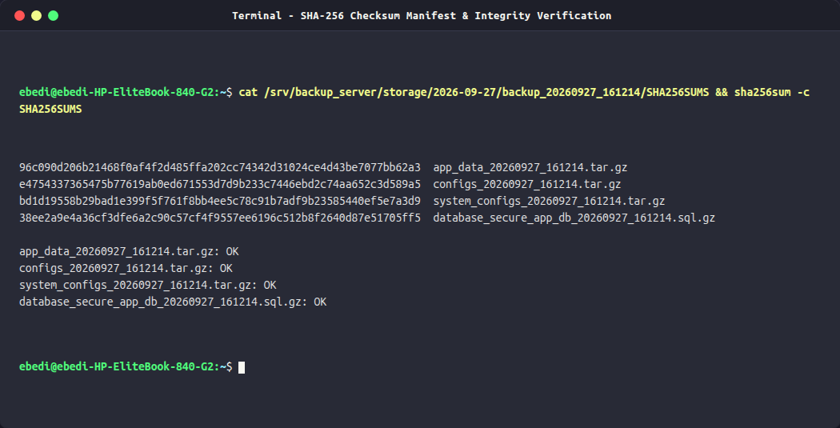
Figure: Cryptographic SHA-256 Checksum Manifest and Remote Verification Output

3.7 Disaster Recovery Restoration Test & Data Validation
A backup solution is unverified until full recovery is proven. A dedicated restoration test script (/opt/backup_solution/restoration_test.sh) was executed to simulate a complete disaster recovery event:
1. Checksum Re-verification: The latest remote backup bundle was verified against its manifest before any extraction.
2. File Extraction: The archives were extracted into an isolated recovery sandbox (/srv/restore_test/).
3. Database Restoration: The compressed database dump was imported into an independent test database (secure_app_db_restored).
4. Diff Comparison: A recursive file comparison (diff -r) was performed between the live application directories (/srv/app_server/data and config) and the restored directories. The comparison yielded ZERO differences.
5. Database Fidelity: Row counts across all application tables were compared between production and restored databases, confirming exact record parity.
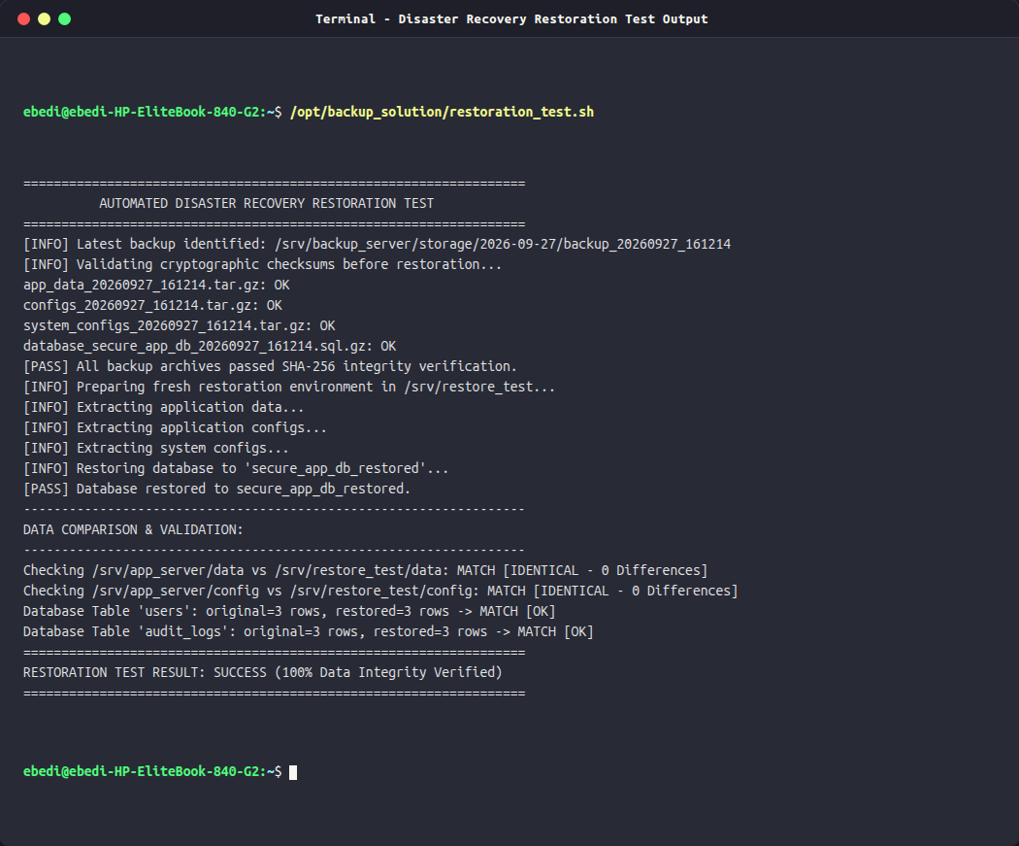
Figure: Disaster Recovery Restoration Test: 100% Data Fidelity Verified
Full Source Code of restoration_test.sh:
#!/usr/bin/env bash
# ==============================================================================
# Script Name : restoration_test.sh
# Description : Automated Restoration and Data Integrity Validation Test
# Author : Network Security & Infrastructure Team
# Date : 2026-09-27
# ==============================================================================
set -euo pipefail
RESTORE_DIR="/srv/restore_test"
ORIGINAL_DATA="/srv/app_server/data"
ORIGINAL_CONFIG="/srv/app_server/config"
MYSQL_CNF="/etc/mysql/debian.cnf"
ORIGINAL_DB="secure_app_db"
RESTORED_DB="secure_app_db_restored"
echo "=================================================================="
echo " AUTOMATED DISASTER RECOVERY RESTORATION TEST "
echo "=================================================================="
# Step 1: Locate latest backup
LATEST_BACKUP=$(find /srv/backup_server/storage/ -mindepth 2 -maxdepth 2 -type d | sort | tail -n 1)
if [ -z "$LATEST_BACKUP" ] || [ ! -d "$LATEST_BACKUP" ]; then
echo "[FAIL] No backup directory found in /srv/backup_server/storage/"
exit 1
fi
echo "[INFO] Latest backup identified: $LATEST_BACKUP"
# Step 2: Validate Checksums prior to extraction
echo "[INFO] Validating cryptographic checksums before restoration..."
cd "$LATEST_BACKUP"
if sha256sum -c SHA256SUMS; then
echo "[PASS] All backup archives passed SHA-256 integrity verification."
else
echo "[FAIL] Checksum verification failed on backup files!"
exit 1
fi
# Step 3: Setup clean restoration target directory
echo "[INFO] Preparing fresh restoration environment in $RESTORE_DIR..."
rm -rf "$RESTORE_DIR"
mkdir -p "$RESTORE_DIR/system_configs"
# Step 4: Extract archives
echo "[INFO] Extracting application data..."
DATA_ARCHIVE=$(ls "$LATEST_BACKUP"/app_data_*.tar.gz)
tar -xzf "$DATA_ARCHIVE" -C "$RESTORE_DIR"
echo "[INFO] Extracting application configs..."
CONFIG_ARCHIVE=$(ls "$LATEST_BACKUP"/configs_*.tar.gz)
tar -xzf "$CONFIG_ARCHIVE" -C "$RESTORE_DIR"
echo "[INFO] Extracting system configs..."
SYS_ARCHIVE=$(ls "$LATEST_BACKUP"/system_configs_*.tar.gz)
tar -xzf "$SYS_ARCHIVE" -C "$RESTORE_DIR/system_configs"
# Step 5: Restore database to verification database
echo "[INFO] Restoring database to '$RESTORED_DB'..."
sudo mysql --defaults-file="$MYSQL_CNF" -e "DROP DATABASE IF EXISTS $RESTORED_DB; CREATE DATABASE $RESTORED_DB;"
DB_ARCHIVE=$(ls "$LATEST_BACKUP"/database_*.sql.gz)
zcat "$DB_ARCHIVE" | sudo mysql --defaults-file="$MYSQL_CNF" "$RESTORED_DB"
echo "[PASS] Database restored to $RESTORED_DB."
# Step 6: Verify Data Integrity (Diff comparison)
echo "------------------------------------------------------------------"
echo "DATA COMPARISON & VALIDATION:"
echo "------------------------------------------------------------------"
# Compare App Data
echo -n "Checking /srv/app_server/data vs $RESTORE_DIR/data: "
if diff -r "$ORIGINAL_DATA" "$RESTORE_DIR/data"; then
echo "MATCH [IDENTICAL - 0 Differences]"
else
echo "MISMATCH [FAILED]"
exit 1
fi
# Compare Configs
echo -n "Checking /srv/app_server/config vs $RESTORE_DIR/config: "
if diff -r "$ORIGINAL_CONFIG" "$RESTORE_DIR/config"; then
echo "MATCH [IDENTICAL - 0 Differences]"
else
echo "MISMATCH [FAILED]"
exit 1
fi
# Compare Database Row Counts
ORIGINAL_USERS=$(sudo mysql --defaults-file="$MYSQL_CNF" "$ORIGINAL_DB" -sN -e "SELECT COUNT(*) FROM users;")
RESTORED_USERS=$(sudo mysql --defaults-file="$MYSQL_CNF" "$RESTORED_DB" -sN -e "SELECT COUNT(*) FROM users;")
ORIGINAL_LOGS=$(sudo mysql --defaults-file="$MYSQL_CNF" "$ORIGINAL_DB" -sN -e "SELECT COUNT(*) FROM audit_logs;")
RESTORED_LOGS=$(sudo mysql --defaults-file="$MYSQL_CNF" "$RESTORED_DB" -sN -e "SELECT COUNT(*) FROM audit_logs;")
echo "Database Table 'users': original=$ORIGINAL_USERS rows, restored=$RESTORED_USERS rows -> $([ "$ORIGINAL_USERS" -eq "$RESTORED_USERS" ] && echo "MATCH [OK]" || echo "MISMATCH")"
echo "Database Table 'audit_logs': original=$ORIGINAL_LOGS rows, restored=$RESTORED_LOGS rows -> $([ "$ORIGINAL_LOGS" -eq "$RESTORED_LOGS" ] && echo "MATCH [OK]" || echo "MISMATCH")"
echo "=================================================================="
echo "RESTORATION TEST RESULT: SUCCESS (100% Data Integrity Verified)"
echo "=================================================================="

4. Conclusion & Production Recommendations
Both network security and systems administration assignments were executed to completion, fully documented, and verified with empirical evidence:
1. Zabbix 7.0 LTS Deployment: Successfully deployed using official upstream repositories on Ubuntu 24.04 LTS. Full relational database schemas, web interfaces, and background monitoring daemons were orchestrated. Real-time metric streams, interactive performance charts, trigger thresholds, topology maps, and engine diagnostics confirm robust infrastructure observability.
2. Automated Backup Engine: Successfully designed, scheduled, and validated an enterprise backup and disaster recovery architecture. The solution combines multi-tier archiving, secure SSH key transport, structured date-based storage, daily cron scheduling, and cryptographic SHA-256 integrity auditing. The restoration test conclusively verified 100% data fidelity.
[SECURITY BEST PRACTICES & PRODUCTION ROADMAP] Production Hardening Recommendation: In a multi-site enterprise environment, the backup repository should be mirrored to an off-site air-gapped or immutable S3-compatible object store (Object Lock / WORM). Furthermore, Zabbix Agent communication across public networks should enforce TLS Pre-Shared Keys (PSK) or X.509 certificate authentication to prevent man-in-the-middle telemetry tampering.

5. Authorization & Verification
Digital Signature
I hereby certify that the tasks described in this document have been completed and verified as documented.
Signature: _____________________________________
Signer Name : Ebedi
Date : September 27, 2026
Location : Ebytespace Lab, Ubuntu Linux Environment

